Name : Kasak Patel
Roll No : 05
Sec-Batch : B-B1
ML Lab 2

Objectives
- To load and examine the USA Housing dataset using Python and Pandas.
- To understand the features of the dataset and identify Price as the target variable.
- To check for missing values and duplicate records in the dataset.
- To remove the Address feature as it is not required for the regression analysis.
- To detect and handle Price outliers using the IQR method.
- To visualize the dataset using box plots, histograms, scatter plots, and a correlation heatmap.
- To separate the input features from the target variable Price.
- To standardize the input features using StandardScaler.
- To divide the dataset into training and testing sets.
- To develop a Simple Linear Regression model for predicting house prices using average area income.
- To evaluate the model using Mean Absolute Error (MAE), Mean Squared Error (MSE), Root Mean Squared Error (RMSE), and R² Score.
- To predict the house price for a given average area income.
- To implement Ridge Regression and find a suitable alpha value using GridSearchCV.

1.0 Theory
Linear Regression is a supervised machine learning technique used to study the relationship between input variables and a continuous output variable. In this experiment, regression is applied to the USA Housing dataset to estimate house prices using different property-related attributes. Before developing the model, the dataset is examined and prepared so that the input data is suitable for regression analysis.

1.1 Dataset Inspection
The first step in building a machine learning model is to understand the dataset. The USA Housing dataset contains information such as average area income, average house age, average number of rooms, average number of bedrooms, area population, price, and address. Functions such as head(), isnull(), duplicated(), info() and describe() are used to examine the records, data types, missing values and statistical characteristics of the dataset. The dataset contains 5000 records, and the numerical features are stored as floating-point values.

1.2 Data Cleaning and Feature Selection
Data cleaning is performed to make the dataset appropriate for model training. Missing values and duplicate records are checked before further processing. In this experiment, no missing values or duplicate observations are found. The Address column is removed because it is a text-based identification field and is not used as a numerical predictor for the regression model. After removing this feature, the dataset contains six numerical columns, including the target variable Price.

1.3 Statistical Analysis and Outlier Detection
Descriptive statistics are useful for understanding the distribution of numerical features. Measures such as mean, standard deviation, minimum, maximum and quartile values are obtained using the describe() function. Box plots are then used to visually examine possible extreme values in variables such as Price, Average Area Income and Area Population.
The Interquartile Range (IQR) method is used to identify unusual values in the Price feature. The IQR is calculated as:
IQR = Q3 − Q1
The acceptable range is determined using:
Lower Limit = Q1 − 1.5 × IQR
Upper Limit = Q3 + 1.5 × IQR
Values outside these limits are removed from the dataset. Histograms are then used to observe the distribution of the cleaned numerical variables.

1.4 Data Visualization and Correlation
Visualization helps in understanding the relationship between different variables.
Scatter plots are used to observe the relationship between Avg. Area Income and Price, as well as between Area Population and Price. A correlation heatmap is also created for numerical variables to examine the strength and direction of their relationships. These visualizations help in understanding which features may be useful for predicting house prices. 1.5 Feature and Target Variable
In regression, the variables used to make predictions are called independent or input variables, while the value being predicted is called the dependent or target variable. In this experiment, Price is selected as the target variable, while the remaining numerical attributes are used as input features. The dataset is divided into X for independent variables and y for the target variable.

1.6 Feature Scaling and Train-Test Split
Feature scaling is applied so that numerical input variables are placed on a comparable scale. The StandardScaler technique is used to standardize the input features before model development. The prepared dataset is then divided into training and testing portions using train_test_split(). In this experiment, 80% of the data is used for training and 20% for testing. The training data is used to build the model, while the testing data is used to evaluate its performance on unseen observations.

1.7 Simple Linear Regression
Simple Linear Regression is a regression method that establishes a linear relationship between one independent variable and a continuous dependent variable. In this experiment, Avg. Area Income is selected as the independent variable and Price is considered the dependent variable. The LinearRegression class from Scikit-learn is used to train the model. The general equation of simple linear regression is:
y = b + b x
where y represents the predicted price, x represents average area income, b is the intercept and b is the slope of the regression line. After training, the model predicts house prices for the testing data.

1.8 Model Performance Evaluation
The performance of the regression model is measured using different evaluation metrics. In this experiment, Mean Absolute Error (MAE), Mean Squared Error (MSE), Root Mean Squared Error (RMSE), and R² Score are calculated.
- MAE represents the average absolute difference between actual and predicted values.
- MSE calculates the average squared prediction error.
- RMSE is the square root of MSE and expresses the error in the same units as the target variable.
- R² Score indicates how well the model explains the variation in the target variable.
These measures help determine how effectively the regression model predicts house prices.

1.9 Price Prediction
After training the Simple Linear Regression model, it can be used to predict the price of a house for a given average area income. In the experiment, an income value is entered by the user and passed to the trained model to obtain the estimated house price. For example, the notebook demonstrates prediction using an average area income of 80000.

1.10 Ridge Regression
Ridge Regression is a regularized form of linear regression that is used to reduce the effect of overly large model coefficients. It introduces a regularization parameter called alpha, which controls the strength of the regularization. In this experiment, Ridge Regression is applied and its performance is compared using the R² score.
Different alpha values are tested using GridSearchCV with 5-fold cross-validation to identify a suitable value for the model. The experiment tests alpha values ranging from 0.001 to 100, and the best alpha obtained in the notebook is 100.

1.11 Regression Visualization
A regression plot is generated to visually compare the actual house prices with the predicted values. The testing data is represented using points, while the fitted regression line represents the relationship learned by the Simple Linear Regression model. This graphical representation makes it easier to understand how closely the predictions follow the actual observations.

2. Materials and Software Used
- Python 3.x – Used for implementing the machine learning program.
- Google Colab / Jupyter Notebook – Used to write and execute the Python code.
- Pandas – Used for loading, processing, and analyzing the USA Housing dataset.
- NumPy – Used for numerical calculations and handling arrays.
- Matplotlib – Used for creating graphs and visualizing the results.
- Seaborn – Used for box plots, histograms, scatter plots, and correlation heatmap.
- Scikit-learn – Used for data scaling, train-test splitting, Linear Regression, Ridge Regression, evaluation metrics, and GridSearchCV.
- USA_Housing.csv – Dataset used for predicting house prices.

3. Procedure
- Import the required Python libraries such as Pandas, NumPy, Matplotlib, Seaborn, and Scikit-learn.
- Load the USA_Housing.csv dataset into a Pandas DataFrame.
- Display the first few records of the dataset using df.head().
- Check the dataset for missing values using df.isnull().sum().
- Check for duplicate records using df.duplicated().sum().
- Remove the Address column because it is not required for the regression analysis.
- Use df.info() and df.describe() to examine the structure and statistical details of the dataset.
- Create box plots for Price, Average Area Income, and Area Population to identify possible outliers.
- Calculate Q1, Q3, and IQR and remove extreme values from the Price column using the IQR method.
- Create histograms for Price and Average Area Income to study their distributions.
- Create scatter plots to examine the relationships between Average Area Income and Price and Area Population and Price.
- Generate a correlation heatmap for the numerical features.
- Separate the independent variables into X and the target variable Price into y.
- Standardize the input features using StandardScaler.
- Divide the dataset into training and testing data using train_test_split().
- Select Average Area Income as the input variable for Simple Linear Regression.
- Create and train the Linear Regression model using the training data.
- Predict house prices using the trained model.
- Evaluate the model using MAE, MSE, RMSE, and R² Score.
- Display the intercept and slope of the Simple Linear Regression model.
- Plot the actual data points and the regression line.
- Enter a new Average Area Income value and use the trained model to predict the house price.
- Create a Ridge Regression model and calculate its R² Score.
- Apply GridSearchCV with different alpha values to determine the best parameter for Ridge Regression.
- Analyze the obtained results and compare the performance of the regression models.
4. GitHub Repository
GitHub Repository URL: https://github.com/GauriRaut58/Gauri/blob/main/LAB_2_ML_C_52_GAURI_RAUT.ipynb
The program code for the USA Housing price prediction experiment is maintained in a GitHub repository. GitHub is a web-based platform used for storing, managing, and sharing programming projects. It allows the machine learning source code and related project files to be kept in an organized manner.
For this practical, the GitHub repository contains the Jupyter/Google Colab notebook used for implementing the USA Housing dataset analysis and regression models. The notebook includes the Python code for data preprocessing, visualization, Simple Linear Regression, house price prediction, and Ridge Regression.
The repository provides an easy way to access and review the complete practical work. It also helps maintain the program code in a structured form and makes the work available for academic evaluation.
PROGRAM CODE:
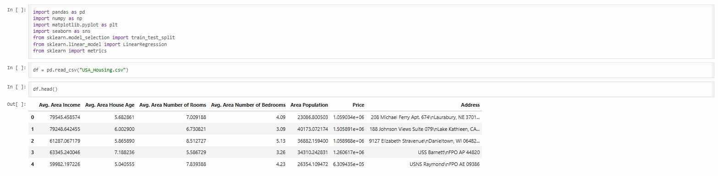
Dataset Loading and Initial Checking
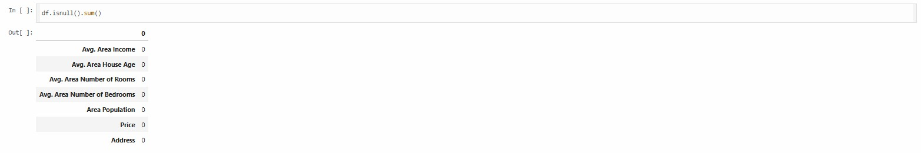

Output Description
The above three code sections are used for the initial examination of the USA Housing dataset. The dataset is successfully loaded and its first five records are displayed. Missing values are checked for all columns, and the duplicate-record check is also performed. The results confirm that the dataset is ready for further preprocessing and analysis.

Data Cleaning and Statistical Analysis
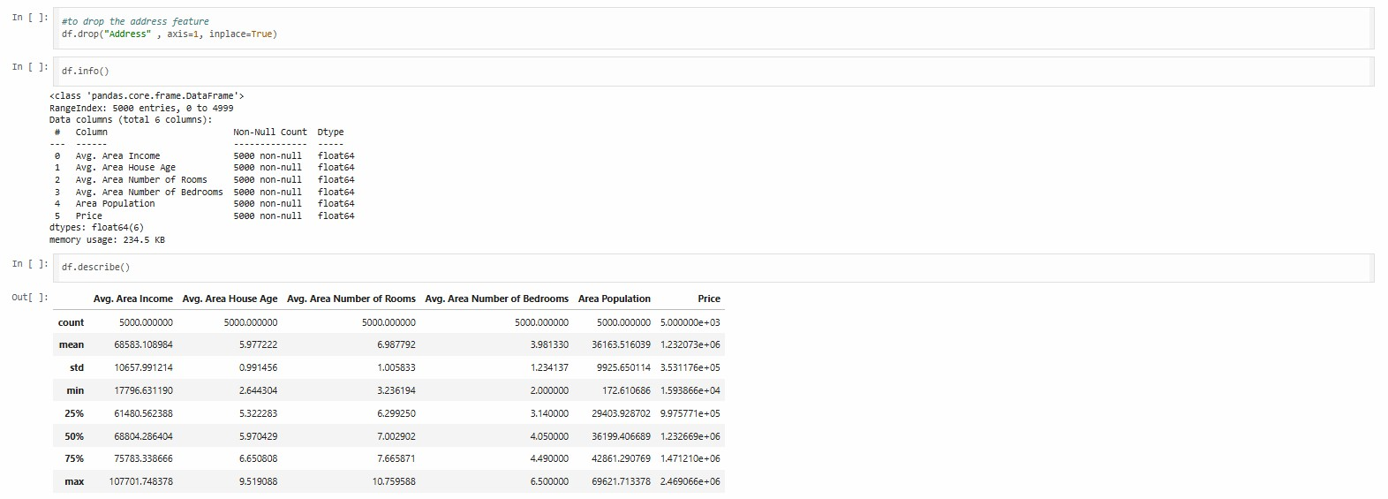
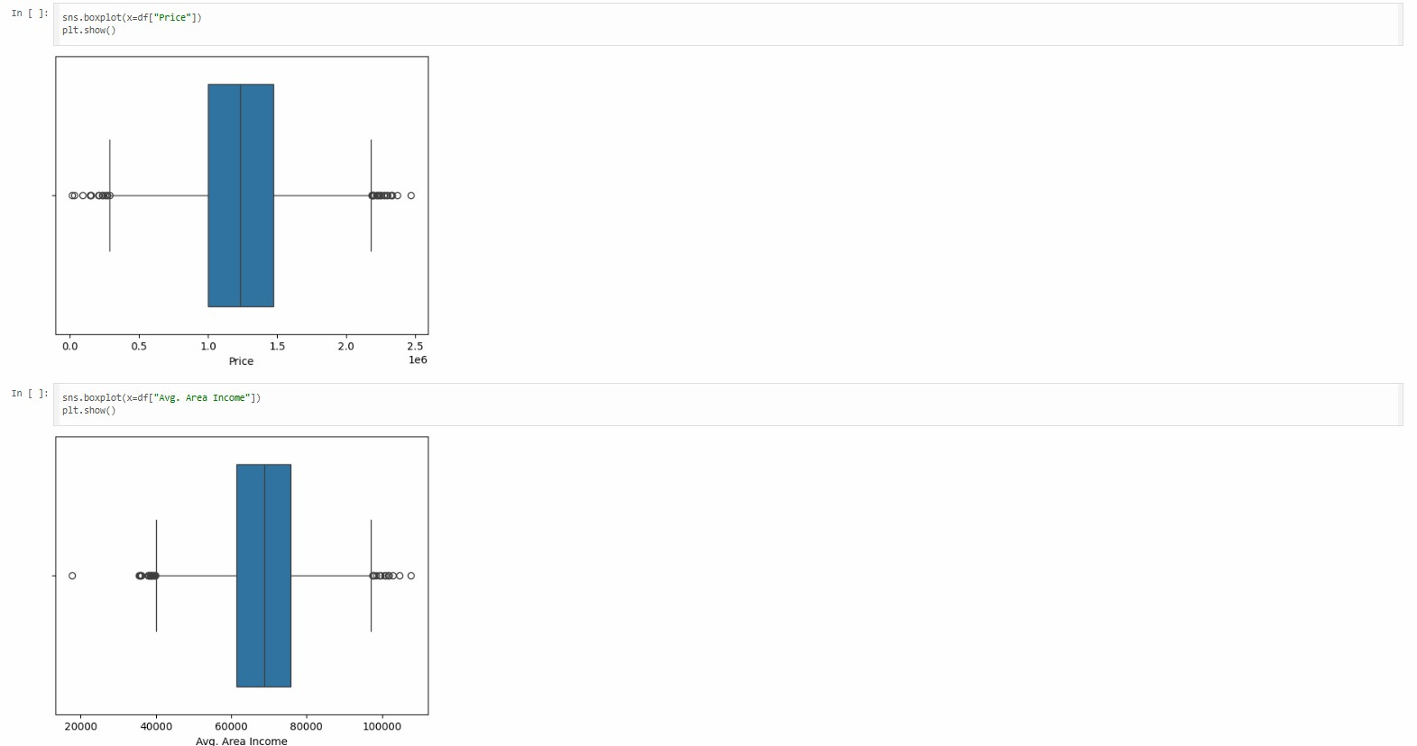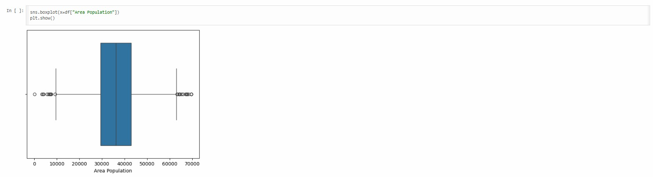

Output Description –
The above three code sections perform data cleaning and statistical analysis. The Address column is removed because it is not required for numerical regression analysis. The describe() function provides statistical information about the numerical features. Box plots are then used to visually examine the distribution and possible outliers in Price, Average Area Income, and Area Population.

Outlier Removal and Visualization
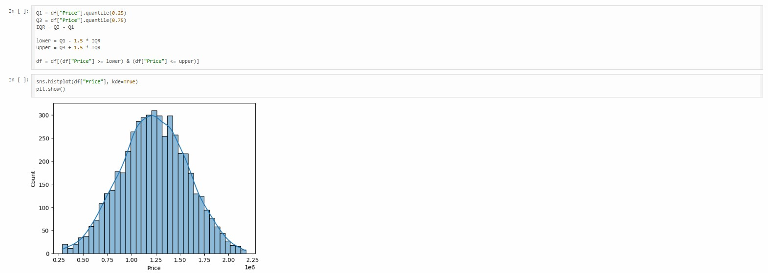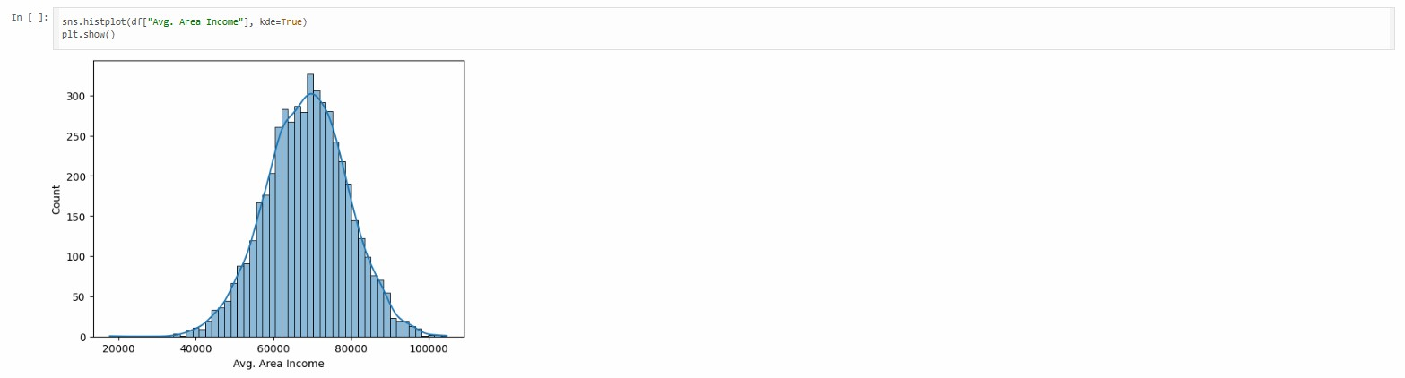

Output Description –
The above three code sections perform outlier handling and visualization. The IQR technique is applied to the Price column to remove extreme observations.
Histograms are generated to understand the distribution of Price and Average Area Income. A scatter plot is also created to visualize the relationship between Average Area Income and Price.

Correlation and Data Preparation
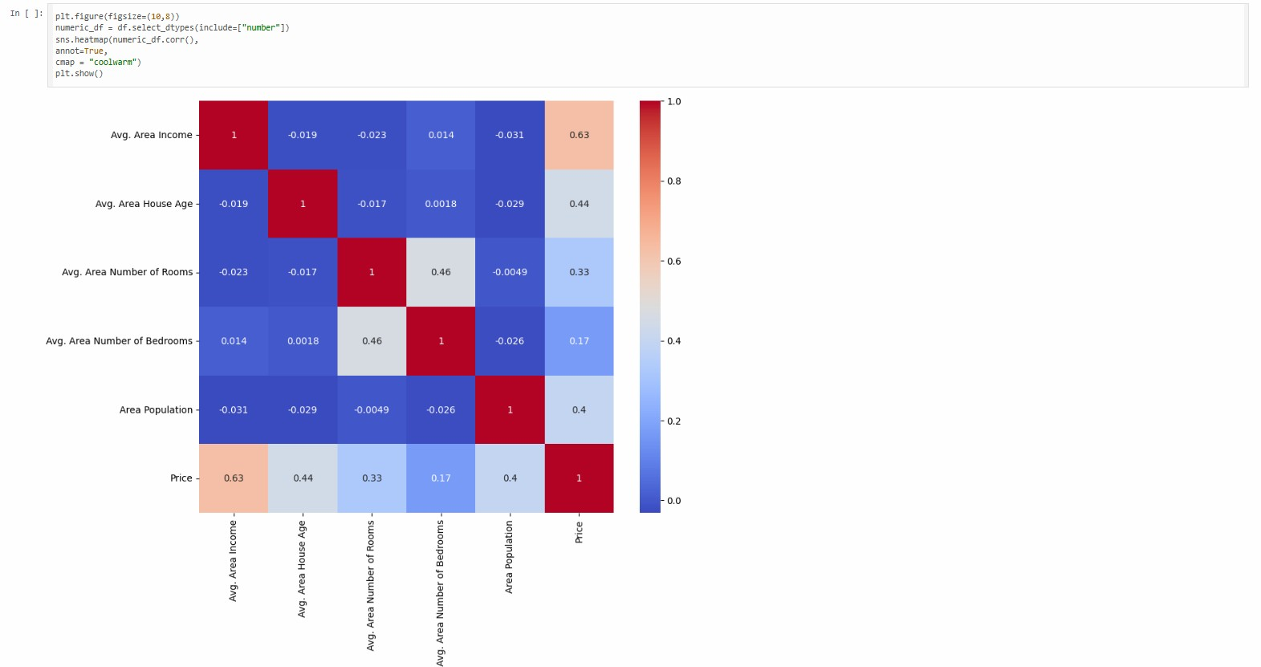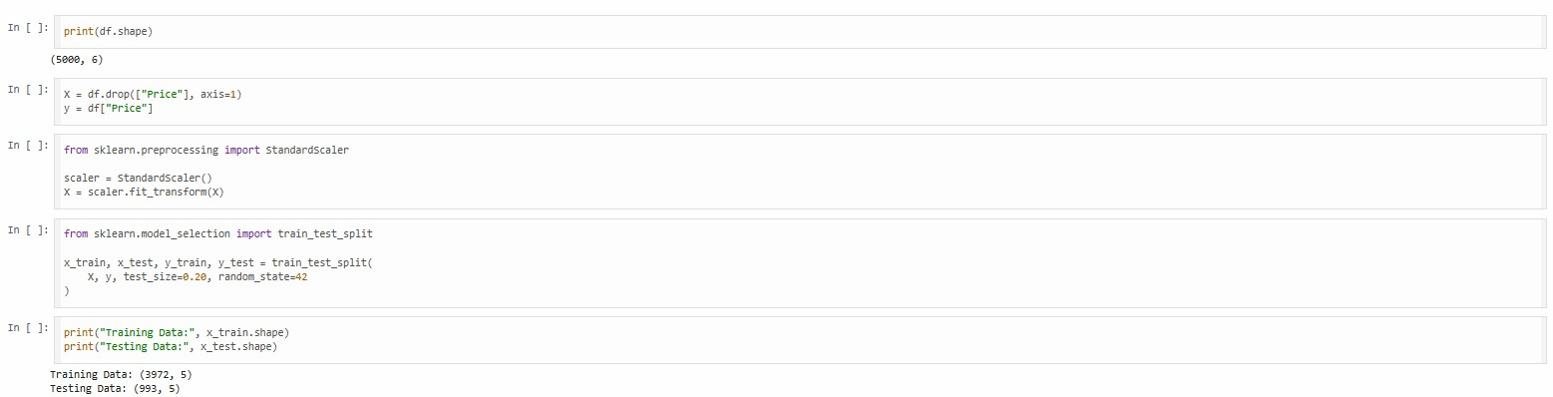

Output Description –
The above three code sections prepare the dataset for machine learning model development. The correlation heatmap shows the relationships among numerical variables. The dataset is divided into input features X and target variable y, where Price is the target. The features are standardized and then divided into training and testing sets for model development and evaluation.

Simple Linear Regression
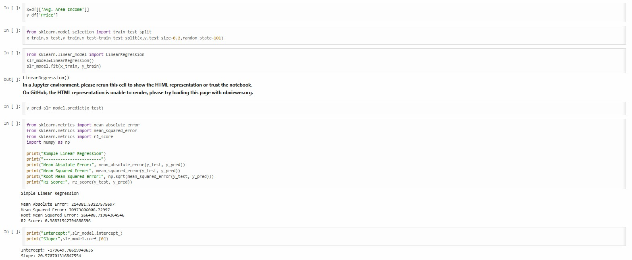

Output Description –
The above three code sections implement and evaluate the Simple Linear Regression model. Average Area Income is used as the independent variable and Price is used as the target variable. The model generates predicted prices and its performance is measured using MAE, MSE, RMSE, and R² Score. The intercept and slope of the fitted regression model are also displayed.

Regression Visualization and Prediction
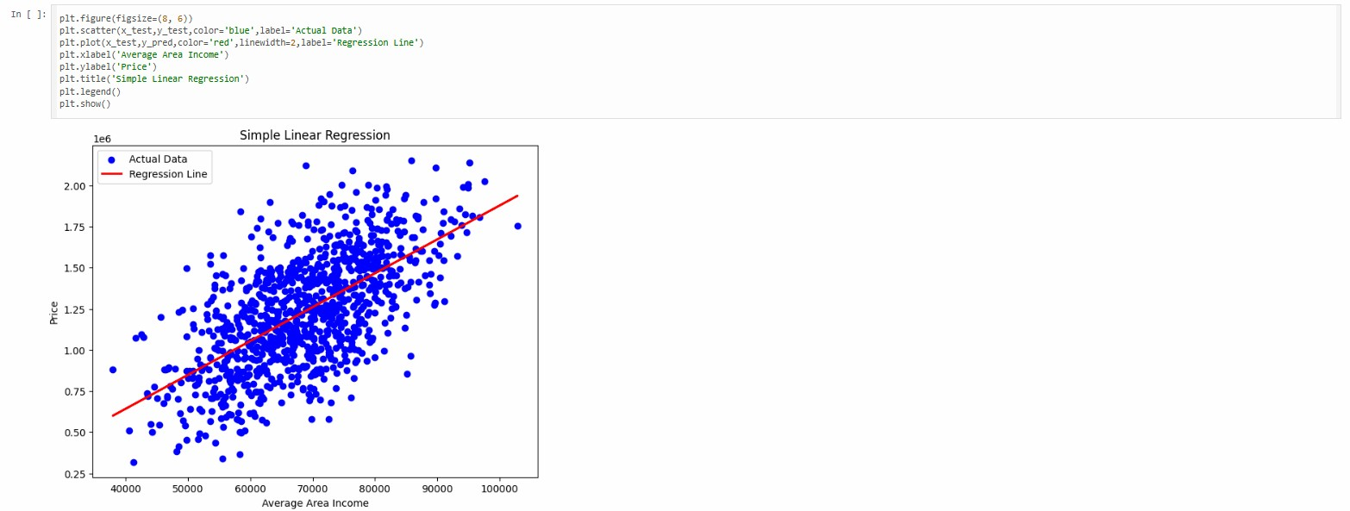
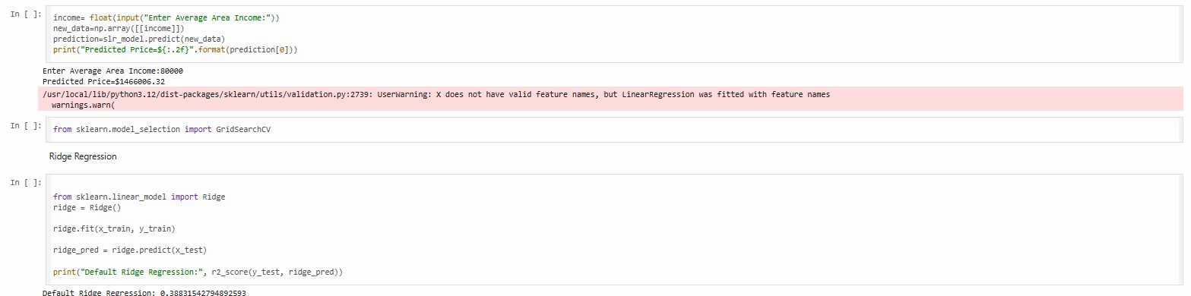

Output Description –
The above three code sections demonstrate regression visualization, house price prediction, and Ridge Regression. The regression graph compares actual observations with the fitted regression line. The trained model is then used to predict the price for a new Average Area Income value. Finally, Ridge Regression is implemented and its performance is evaluated using the R² Score.

Ridge Regression Hyperparameter Tuning
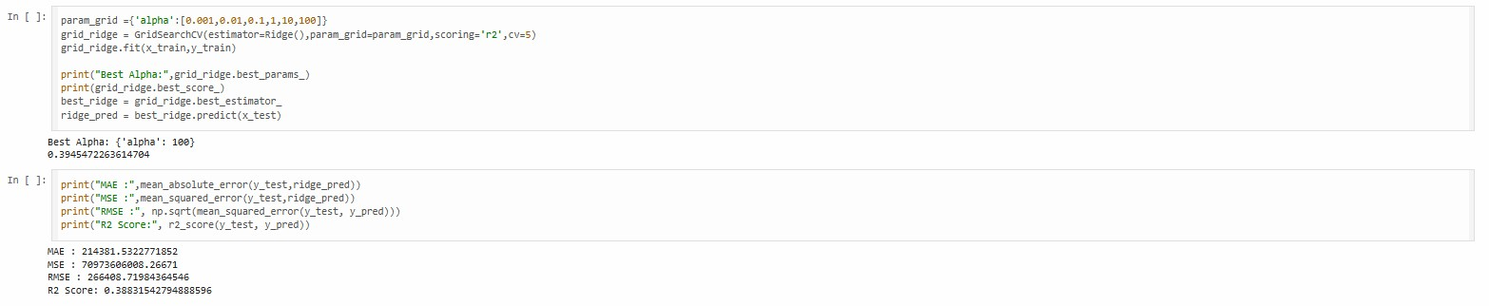

Output Description –
The above three code sections perform hyperparameter tuning for Ridge Regression. Different alpha values are tested using GridSearchCV with five-fold cross-validation. The model compares the performance of each alpha value and selects the most suitable one. According to the notebook output, the best alpha value obtained is 100, with a cross-validation R² score of approximately 0.3883.

Result
The USA Housing dataset was successfully preprocessed and analyzed for house price prediction. Missing values and duplicate records were checked, the unnecessary Address column was removed, and Price outliers were handled using the IQR method. The data was visualized and standardized before model development. A Simple Linear Regression model was successfully trained using Average Area Income to predict Price and was evaluated using MAE, MSE,
RMSE, and R² Score. Ridge Regression was also implemented, and GridSearchCV identified 100 as the best alpha value in the experiment.
Viva Questions and Answers Q1. What is Linear Regression?
Answer:
Linear Regression is a supervised machine learning technique used to predict a continuous numerical value by finding a linear relationship between input variables and a target variable. In this experiment, it is used to predict house Price.
Q2. Which dataset is used in this experiment?
Answer:
The USA Housing dataset (USA_Housing.csv) is used. It contains housingrelated features such as Average Area Income, Average House Age, Average Number of Rooms, Average Number of Bedrooms, Area Population, and Price.
Q3. Why is the Address column removed?
Answer:
The Address column is removed because it contains text-based information and is not required as a numerical predictor in the regression model.
Q4. What is the IQR method used for?
Answer:
The Interquartile Range (IQR) method is used to identify and remove extreme or unusual values, called outliers. In this experiment, it is applied to the Price column.
Q5. What is Ridge Regression?
Answer:
Ridge Regression is a regularized version of Linear Regression. It adds a regularization parameter called alpha to control the model and reduce the effect of large coefficients. In this experiment, GridSearchCV is used to find a suitable alpha value, and the best value obtained is 100.

Conclusion
The experiment successfully demonstrated the complete process of developing a house price prediction model using the USA Housing dataset. The dataset was inspected, cleaned, visualized, and prepared for machine learning. Simple Linear Regression was implemented to predict house prices using Average Area Income, and its performance was evaluated using different regression metrics.
Ridge Regression was also implemented and optimized using GridSearchCV. Thus, the experiment provided practical understanding of data preprocessing, visualization, Linear Regression, model evaluation, prediction, and Ridge Regression.

